Case 3-SEALS-Afghanistan
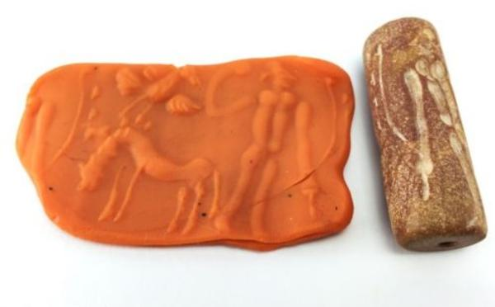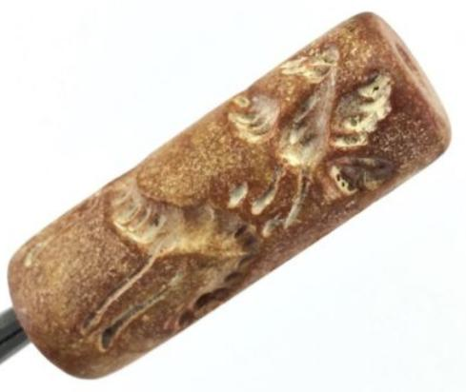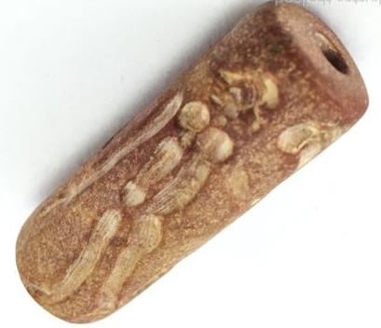
ORDER DATE  Apr 05, 2016 | ORDER TOTAL  US $24.90  + US $6.00  shipping  Order BIG Vintage Human Bird Horse Stamp Seal Old Afghanistan Carved Garnet Bead U78 Leave feedback - ORDER DATE Apr 05, 2016View order details - ORDER DATE Apr 05, 2016  More actions - ORDER DATE Apr 05, 2016
1 item sold by luckystar-thailand
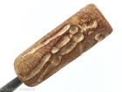  BIG Vintage Human Bird Horse Stamp Seal Old Afghanistan Carved Garnet Bead U78  ( 152033225899 )  Estimated delivery Fri, Apr 22 - Thu, May 05  Tracking number: Tracking numberRR076150504TH  Add note |  |  |  | ITEM PRICE:  US $24.90
 | ORDER DATE  Apr 01, 2016 | ORDER TOTAL  US $177.00  Free shipping  Order Stunning Beauty old Carved Agate Seal Stamp bead,Gloriouse Beauty Old Afghan greek king Ancient Black Stone seal stamp bead,Gloriouse Beauty Old Afghan seal stamp bead View order details - ORDER DATE Apr 01, 2016Contact seller - ORDER DATE Apr 01, 2016  More actions - ORDER DATE Apr 01, 2016
3 items sold by kselleronline
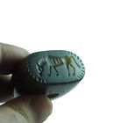  Stunning Beauty old Carved Agate Seal Stamp bead  ( 152002889039 )  Estimated delivery Thu, Apr 21 - Wed, May 04  Tracking number: Tracking numberRr174550263th  Add note | ITEM PRICE:  US $17.00 | Item Stunning Beauty old Carved Agate Seal Stamp bead Orders 152002889039-0-1388091279005Leave feedbackReturn this item  More actions

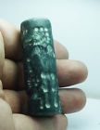  Gloriouse Beauty Old Afghan greek king Ancient Black Stone seal stamp bead  ( 152006081725 )  Estimated delivery Thu, Apr 21 - Wed, May 04  Tracking number: Tracking numberRr174550263th  Add note | ITEM PRICE:  US $100.00 | Item Gloriouse Beauty Old Afghan greek king Ancient Black Stone seal stamp bead Orders 152006081725-0-1388090821005Leave feedbackReturn this item  More actions

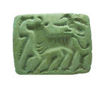  Gloriouse Beauty Old Afghan seal stamp bead  ( 161999074682 )  Estimated delivery Thu, Apr 21 - Wed, May 04  Tracking number: Tracking numberRr174550263th  Add note | ITEM PRICE:  US $60.00
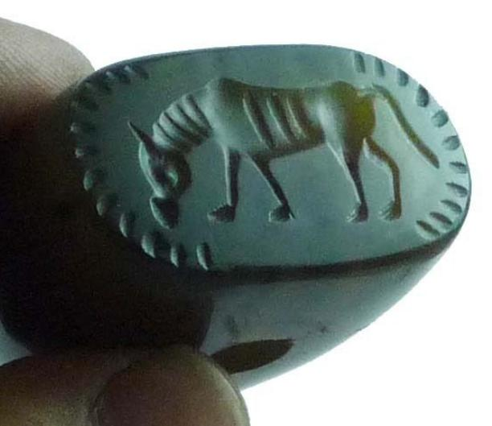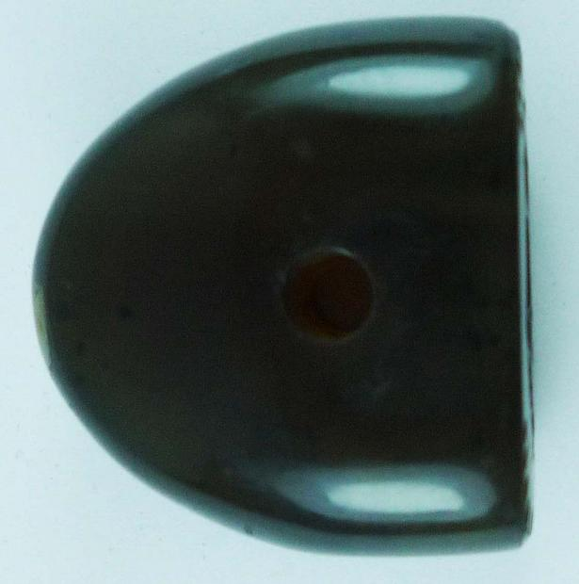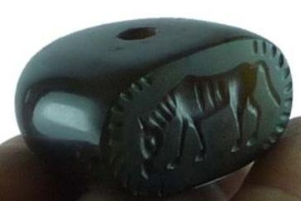
Very nice old carved agate seal stamp bead from north Afghanistan.these beads were used as seal stamp mostly people used az personal
stamp,these beads mostly found in balkh province of Afghanistan.
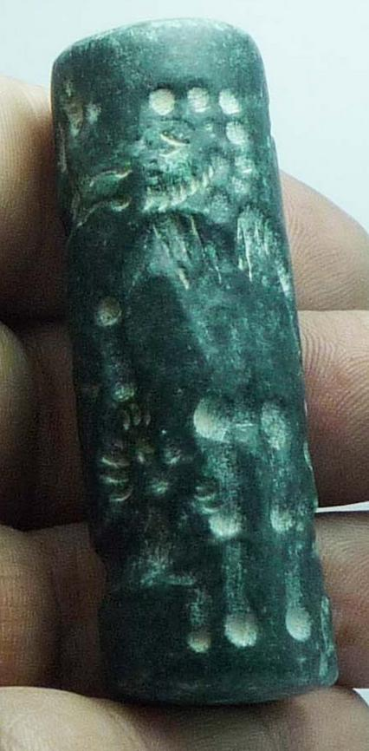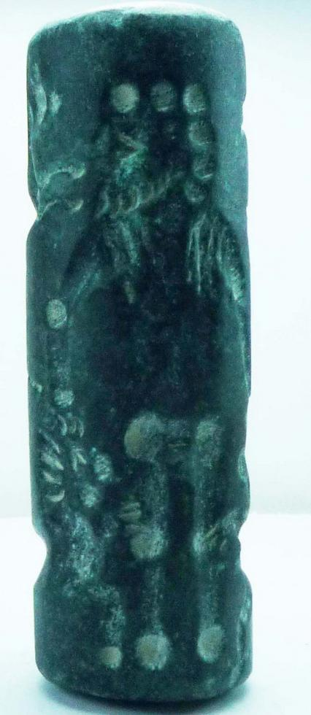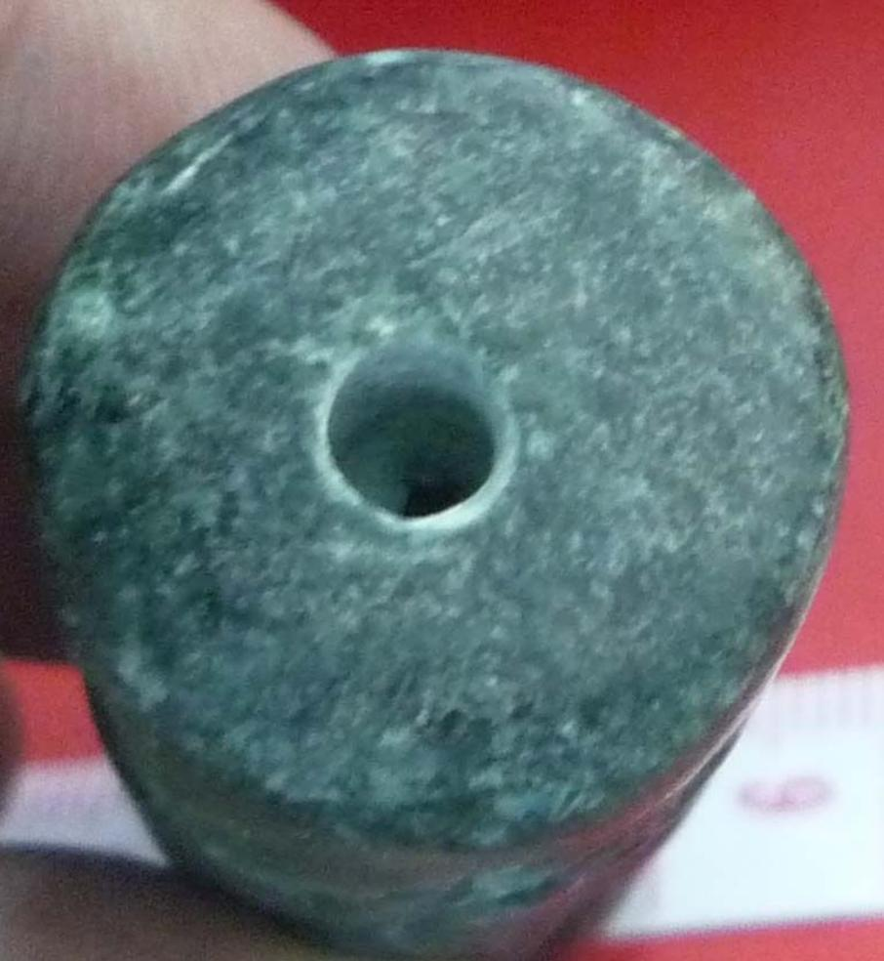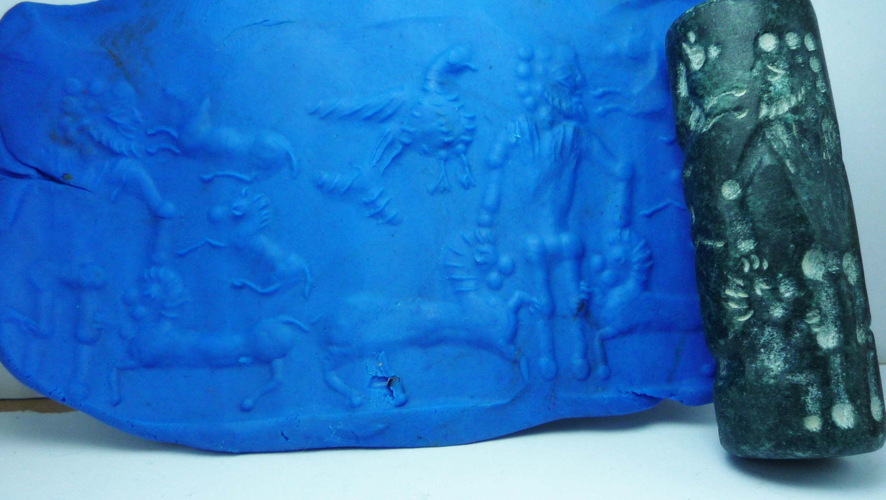
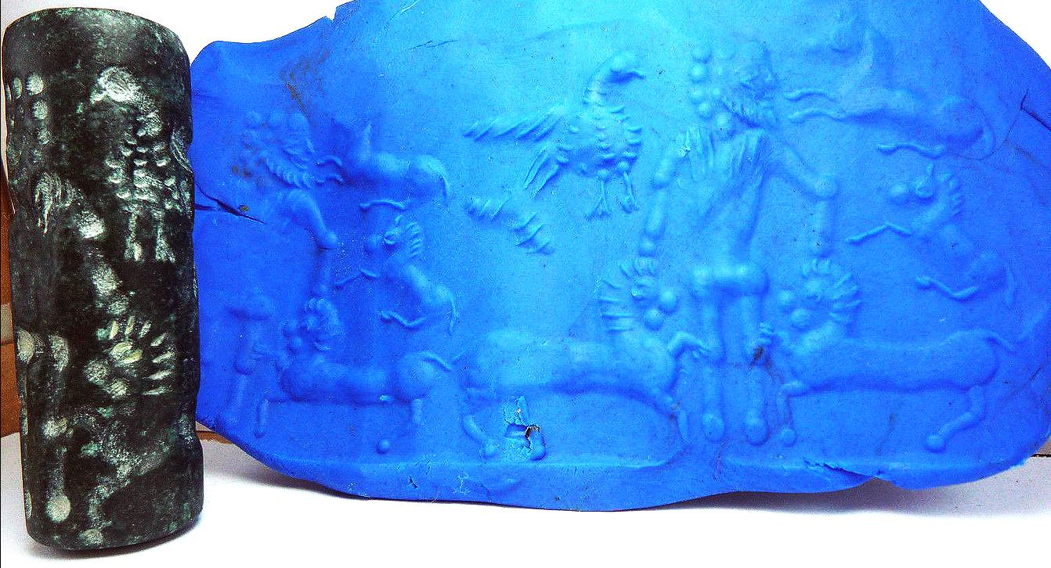

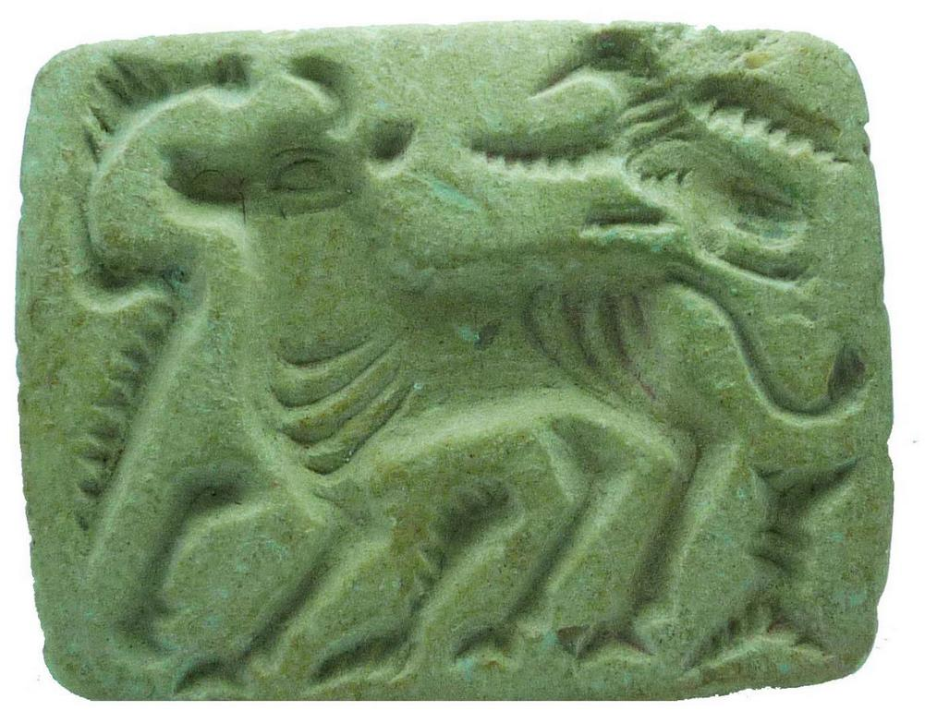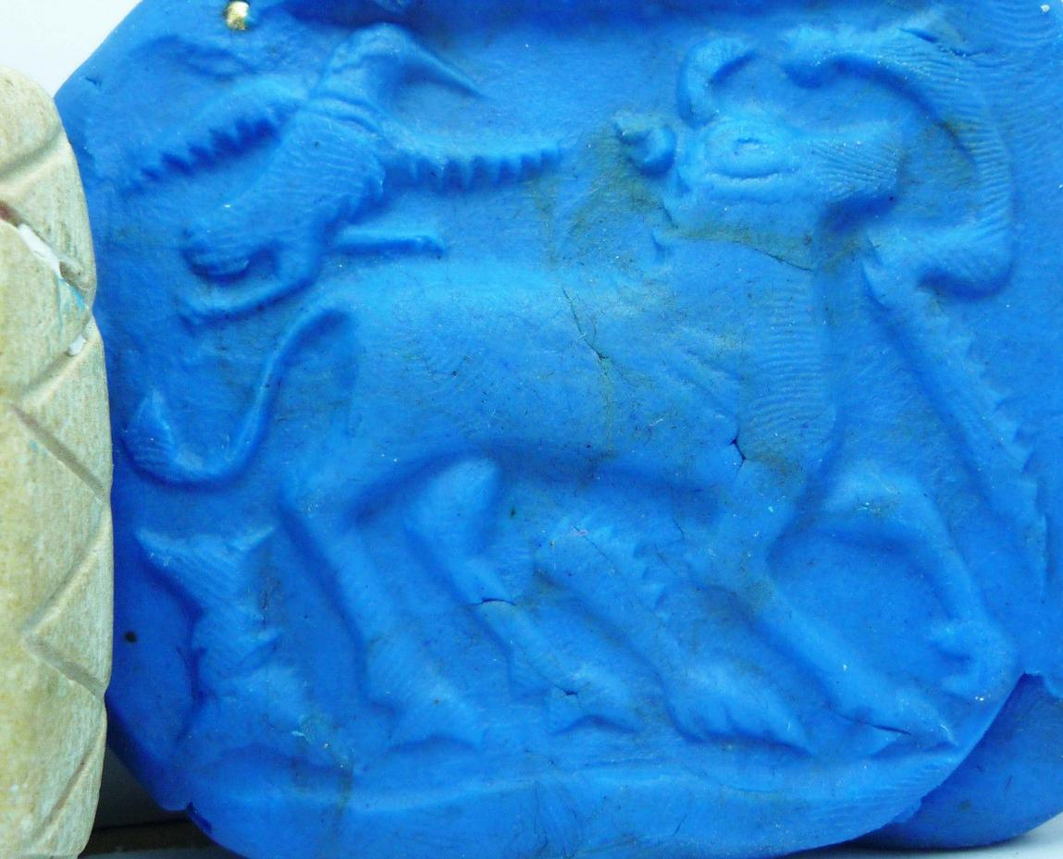
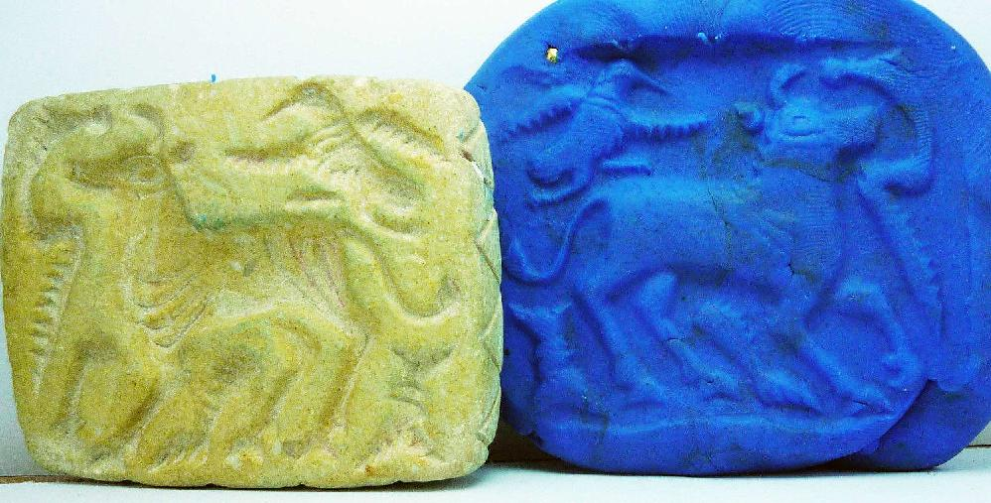
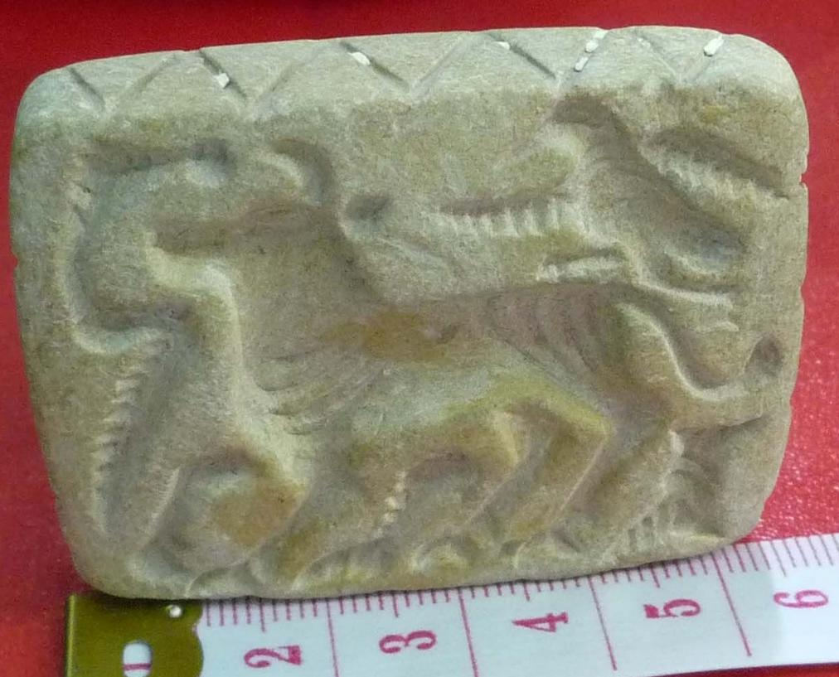

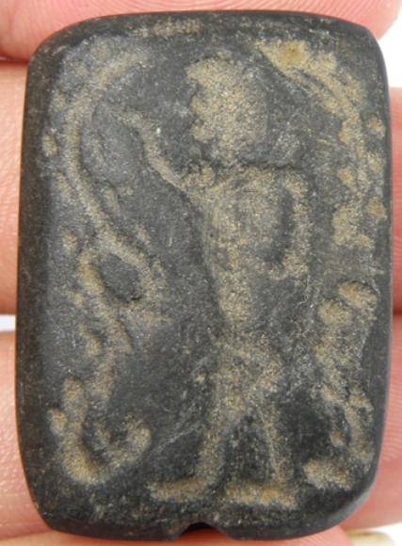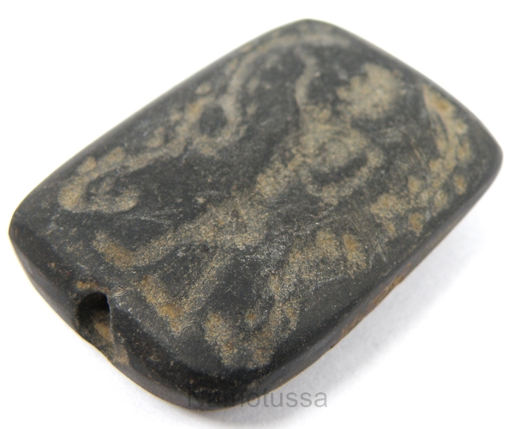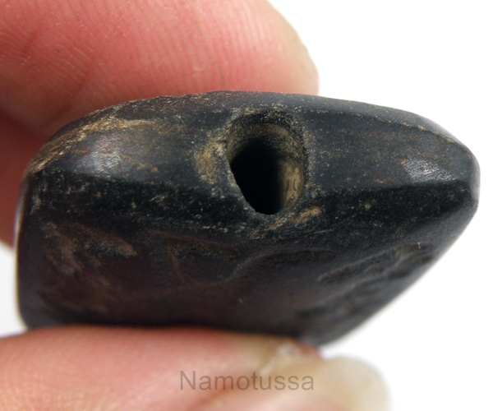
Beautiful Collection Stamp Bead
Quantity PC(s) : | 1
Weight : | 14 g.
Size : | 24 x 33 mm.
Thickness : | 10 mm.
Hole Size : | 3 mm.
Shape : | Rectangle Shape
Stone Type : | Black Stone

